**DOG KINGDOM BOOK ONE**

**By Kristin Johnson WGA  #2011957**

Chapter One: We Have Your Sister



Kim Vallone, ten, stood before the antique cherry wood door that hung on her parents’ wall. Her heart pounded, or it would, if she could feel her heart.

She felt nothing.

Until she opened that door and entered a subterranean maze to rescue her sister Allie, she had no heart.

Oh, she knew she still had a heart. Obviously. Yet she couldn’t feel it. Her heart belonged with her sister, locked away in the deepest dungeon in the dog kingdom.

Kim shuffled her feet and wished more than anything that she listened to her mother and drank her hot water with lemon this morning. She’d have more energy and her brain would work a lot better.

She wished she sat in her own kitchen or bedroom, with Allie annoying her while she read a good fantasy book or biography of a famous scientist, especially a *woman* scientist, or of Martha Stewart. Allie tried to read but had learning disabilities. Give her credit: she did listen to an audiobook of Harry Potter.

Kim clasped the paw-shaped rose quartz pendant that appeared under her pillow with the note that shattered her world. She held the note and read it.

*Kimberley Vallone—*

*We have your sister Allison, your littermate.*

*Your family owes the Dog Kingdom a life-debt. Two mating seasons ago your parents captured our princess, whom you called “Missy,” and kept her as a slave, a human* pet. *We are not your tame dog servants begging for food and affection. We rule all dogs. Or we did before you humans humiliated us. Now we demand payback. Your sister will serve us forever unless you return the princess.*

*Bring the princess to us if you want to see your litter-mate again.*

*Open the door on the wall with the princess’s amulet. Find our kingdom. It won’t be easy. You have until the wolf moon.*

*Queen Cora, Dog Kingdom*

Kim swallowed and turned over her poodle Missy’s dog collar in her hands. Its heart-shaped tag read: “Missy Vallone. If Found Please Call…”

A month ago Missy ran away.

Kim almost threw up thinking about it. The memory of Missy’s expressive face with big eyes haunted her. Kimberley’s BFFs Dylan and Ping said Missy had to be a poodle mix, because of her terrier-like ears. Kimberley didn’t care.

She wanted Missy back. And Allie.

But this Dog Kingdom wanted its princess too…and Kimberley couldn’t help them. They would be angrier than they sounded in the note. Furious. Which meant that Allie might be trapped forever. And even if the Dog Kingdom forgave her, she didn’t have much time. Tomorrow night marked the wolf moon.

Poor Allie. Imprisoned in some yucky dungeon, maybe. Kim never thought dogs had dungeons. Allie threw things and bounced off the walls if her parents gave her a time-out. Hyperactive, the school called it. Disruptive. What would she do locked up in a dog dungeon? Did they even have her locked up? Maybe they put her in chains and made her wait on all the dogs.

Kim tried the door, which her parents nailed it to the wall. “A conversation piece,” they called it. Weird, beyond weird. And her only chance to rescue Allie.

Kim’s mom Emily, short black hair identical to Kim’s, charged toward her locomotive-style. “Kimberley Rachel Vallone, I have been calling you for ten minutes. Have you gone deaf?”

The worry lines on Emily’s face made Kim’s stomach twist. “I’m just thinking.” She stuffed the note inside the pocket of her favorite red shorts.

“Well, think and answer me at the same time. And we need you to stay close to the phone. In case your sister calls.”

Kim fingered the note in her pocket. Should she tell her mom? Show her the note? Unless it turned out to be some kind of sick joke? But no, impossible. Who would play a trick like that?

“Why did you nail this door to the wall, Mom?”

“I don’t have time for that now. Your dad and I have to go out with the search party again. Stay by the phone.” Emily gestured at the kitchen. “Aunt Vicky is here with you.”

*Great.*

Kim hugged her mom goodbye. “Find her.”

Aunt Vicky, her shiny perfect blonde hair flying, burst out of the kitchen. “Oh, Kim, baby, I know this is hard. Let’s do something while we wait for your sister. Maybe bake some cookies?”

Kim sighed. She knew Aunt Vicky meant to be nice, but Kim couldn’t even think about cookies right now.

Aunt Vicky tried again. “What are your sister’s favorites?”

“Molasses.” Kim softened. “Mom’s molasses cookies.”

“Oh good. We’ll make them and she’ll smell them when she gets home. And she will come home. Your parents will find her.”

*No, they won’t. If the note is right.*

Kim heard her mom open the door to the garage, and on impulse Kim ran to her. Kim waved the note. *If you see something, say something. Stranger danger. Tell a grown-up. That’s what Ms. Chu the piano teacher always says to Allie.*

“Kim, what is it?” Emily beckoned to Kim’s father, Mario, who marched back inside. Mario still wore a golf shirt with “EduKids” printed on it, while Emily wore her EduKids button. Kim knew her parents closed their tutoring business to search for Allie. *They should. What’s more important—teaching a bunch of strangers’ kids in math and reading or spending time with your own kids?*

Kim swallowed her fear and gave them the note.

Chapter 2: The Door on the Wall

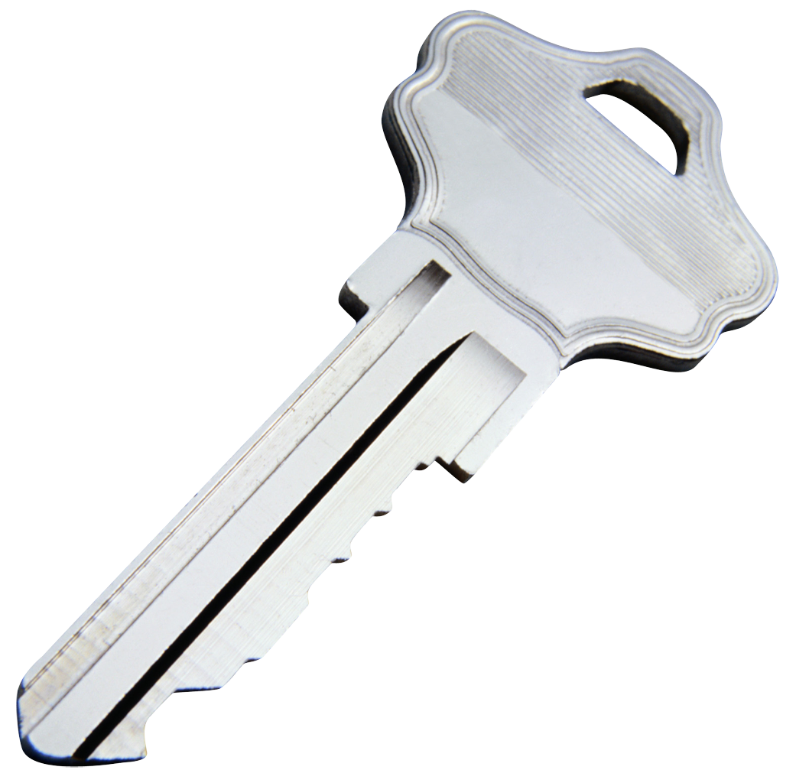

“Mom, Dad, I’m not sure if this note means anything, but I found it in my bedroom. With this.” Kim pointed to the rose quartz paw-print pendant.

Her parents read the note and appeared calm. Their faces didn’t show what they thought. No *is this a joke,* no *you just made that up,* nothing. She wouldn’t believe in something like this.

Her mom said, “Thank you, Kim.”

Mario brushed his mustache with his fingers. It grew so scraggly Kim liked to joke that he kept sticking his tools in sockets at work and that made his mustache weird. What did they call it when they used electricity to remove hair? Not electrocuting. “Thanks. That’s helpful. We’ll give this note to the police.”

“And the pendant?” Kim asked.

“You had that before.” Mario glanced at Emily. “Didn’t she? Your mother gave it to her for her birthday.”

“I thought it was your mother.”

Mario shook his head. “My mom knits her scarves.”

“It came with the note,” Kim said, insistent. *Mom and Dad know I don’t have anything like this. Why are they acting so weird? I mean, I know they’re worried.*

“Sweetie, we’ll talk later. We’re late,” Emily said.

Aunt Vicky’s voice floated behind her. “And we have cookies to make.”

Kim measured out the flour, which spilled. While she did that she thought back four days ago, January 17th.

* * * * *

Kim and her mom waited for Allie to walk the two blocks from her piano teacher’s house. Allie wasn’t supposed to walk alone, but Ms. Chu called and said that today Allie left without waiting for Kim or Ms. Chu to walk her home.

Ten minutes. It took ten minutes to walk the two blocks. More if Allie stopped and visited with her friends in the neighborhood. Longer if she texted. Allie had a basic phone for texts and calls. Kim called it a baby phone.

Kim texted Allie when fifteen minutes passed.

*Where r u?*

*Mom freaking out.*

*I know you just stopped to say hi to people.*

*Just tell me where so I can tell them.*

Nothing from Allie.

*What’s up with you?*

*Why aren’t you answering?*

*Mom trying not to yell.*

*Mom calling your friends now. Total embarrassment. Text me back so we can stop her.*

Still nothing from Allie.

*I am so mad at you. You know how Mom gets.*

Nothing.

Kim and her mom walked the quiet streets lined with palm trees and tamarisk trees. No sign of Allie.

Kim smelled lemonade, Allie’s favorite, and spotted a lemonade stand run by Allie’s friend Madison. Any time Madison put up a lemonade stand, Allie would stroll up and down nearby and bother the heck out of neighbors until they bought lemonade. Today, however, Madison hadn’t seen Allie. No clue.

No one in the neighborhood knew where Allie went.

*Where r u?*

Fifteen minutes turned into the longest day of Allie’s life, even when the police came to ask questions. Then a sleepless night. Then two days of crawling under the covers and fearing she could be next. She could disappear too.

The locket arrived on the third day.

* * * * *

The chime of the oven pre-heating jolted Kim out of her memories. She and Aunt Vicky mixed the ingredients. The fresh scents of flour and molasses comforted Kim, but she missed Allie all the more. Especially the way Allie scraped the mixing bowl with the spatula. Allie had a knack for it. Kim never possessed Allie’s luck with the cookie dough.

Once the cookies baked in the oven, Aunt Vicky suggested more activities they could do. “We could watch a DVD, or I’d love to hear you read the book I sent you last week. Anything. Maybe do some of the crafts you and your sister like.”

Allie and Kim only did one craft together in their lives, but Allie didn’t feel like correcting Aunt Vicky. “I think I just want to read by myself,” she said.

“Oh sweetie. You shouldn’t be alone right now.”

Aunt Vicky could be nice, but she never had kids and didn’t know anything about what Allie needed Allie stalked to the family room and her favorite spot in-between the sofa and the armchair. She flopped on the floor with her book. Aunt Vicky chose the sofa and settled in with a book.

A thump-thump made Kim forget the bit in her book about Albert Einstein’s childhood, the way he liked to sail toy boats and the way someone gave him a compass. Thump. Thump.

Allie got up and traipsed toward the sound. It came from the door on the wall. When she came close enough to see the scratches in the wood, she realized something that made her blood turn to ice water.

The door shook.

*Like someone is trying to get out.*

And she noticed that a piece of the wood peeled and hung askew. When she tried to fix it, the fragment came off in her hand. Splinters dug into her fingers, but she ignored them.

In place of the wood, she was a gouge, a hole, shaped like a paw print the exact size of the necklace.

On impulse, Kim took off the rose quartz paw print and pressed it into the hole. It clicked into place.

Kim stepped back and waited.

The door remained a plain door.

*What were you thinking, Kim?*

The doorknob turned.

Chapter Three: Puppy-in-Waiting

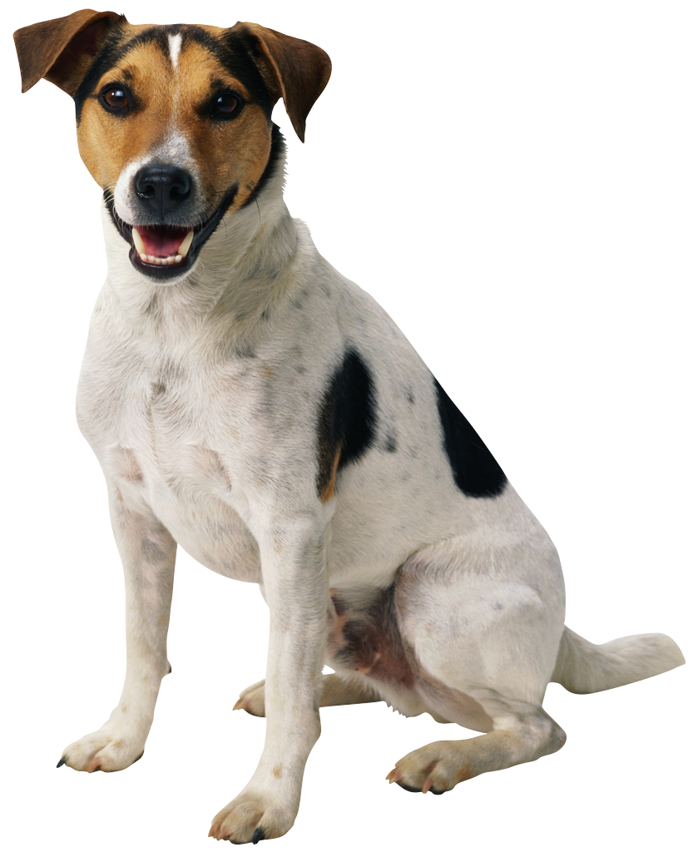

Kim froze and didn’t dare to breathe. Something told her to jump back, and she did.

The door opened. Instead of the sea green wall, Kim saw a child-sized opening. Big enough for a ten-year-old to enter.

Inches away from the opening, a Jack Russell Terrier wagged its tail and dropped a dog biscuit. Kim dove to catch it, turned it over, and saw the words “EAT THIS.” Too much like Alice in Wonderland for words.

“No way,” Kim said to the dog.

The Jack Russell Terrier woofed. Kim noticed the dog wore a jade pendant shaped like a paw print.

“Do you come from the Dog Kingdom?” she asked.

The dog answered with a wagging tail.

Kim shrugged. Sure, if she ate the dog biscuit, she might feel gross for a while and Aunt Vicky would lecture her, but otherwise, she had nothing to lose.

*Except my dignity.*

She crunched the dog biscuit in her mouth and swallowed, then gagged at the taste in her mouth.

“I know it’s not human food.”

Kim jumped and knocked her head against the wooden door. “Ow.”

“Sorry, didn’t mean to startle you.” The words came out of the Jack Russell Terrier’s mouth. “But if you want to see your sister and I want to see my princess again and not be banished forever to the Cavern of Bones, you need to understand what I say. I already speak your language, but it’s not much of a conversation if you don’t speak mine.”

“Wow,” Kim said.

“Wow? As in ‘Bow wow’? Are you trying to speak Canidosian? That’s dog-language to you.”

“No, I mean *wow.* I had no idea I could understand you.”

Aunt Vicky’s voice echoed somewhere nearby. “Kim? Who are you talking to? The cookies will be done soon.”

“My aunt,” Kim said.

“Well, introduce her to me. I’d love to meet another human. Of course, everyone in Canidosia, or the Dog Kingdom, thinks I’m a bit weird. By the way, I’m Berna, the royal tutor and puppy-in-waiting. I’m trying to help you help Queen Cora, the mother of the princess, whom you call Missy. I’m not supposed to be helping you and I could get into three hundred kinds of trouble, but I’ve always wanted to meet humans. Where is your aunt?”

“I don’t think I can explain you.”

“What’s to explain? I’m a dog. Humans usually love dogs. Doesn’t your mother-packmate…sorry, aunt…like dogs?” Berna shuddered when her jade pendant glowed. “Oh oh, I’m being called. Either come inside with me, or I’ll come out there.”

“Come where?”

“Into the Dog Kingdom to find your sister.”

Chapter Four: A Cookie and a Dilemma

“But I don’t have Missy…the princess.”

Berna scratched the floor she stood on. “That pup. No end of trouble. We do need to find her.”

“Before the Wolf Moon…I Googled it, it’s tonight. But I can’t leave the house. You don’t understand. My parents are freaking out. They told me to stay here.”

Berna jumped down onto the heather-gray carpet and rolled, then stood with a shake. “Close and lock the door. You know how.”

Kim did, and felt relief when Aunt Vicky stalked into the room in time to miss the telltale door closing. “Don’t wander off like that.”

“I didn’t go out of the house.”

“I heard the door close.”

Kim picked up Berna and cuddled her. “My friends dropped off their dog Berna because they’re going out of town and they thought she’d comfort me.”

Aunt Vicky scratched Berna behind the ears but the terrier shrank back. “Not very friendly, is she?”

“She’s better with kids than adults,” Kim said. “Now, how about those cookies? They smell so delicious.”

Berna looked at Kim with eyes that said *thank you.*

* * * * *

Aunt Vicky took a phone call.

Kim swallowed a warm sweet mouthful of molasses cookie. Berna propped her paws on Kim’s leg and gazed up at her. “What is that?”

“People food,” Kim said. “It’s called a molasses cookie.”

“If you give me a bite, I’ll go look for the dog you call Missy.” Berna looked like she chewed sweat socks drenched in lawn mulch. “Missy. What a ridiculous name. Her true name is regal.”

“What is it?”

“Princess Flora Andira Hartwell Silverpaw.”

“No way.” Kim dropped the half-eaten cookie and Berna snapped it up.

The guide dog licked and smacked her lips. “I like this ‘cookie.’ Can I have another?”

“You can have as many as you want if you find Missy—the princess. “

“Are you coming?”

“Weren’t you listening? *No.* My parents and my aunt would freak. They’re scared. Aren’t your people in the Dog Kingdom scared? Like Queen Cora, Missy’s mom? I’m sure she is, and if she has other puppies, they’re probably not going anywhere either.”

“She doesn’t have any. Missy is her only child and sole heir.”

Kim thought about that. She tried to picture Allie, an only child, and it boggled her imagination. She shuddered when she thought of Allie the only child disappearing. What would her parents do then?

How did they stay so strong? How did they get out of bed and get dressed when no one could find Allie? *Maybe that’s what parents do,* she thought. *But they’re looking in all the wrong places.*

“Are you sure you won’t come with me?” Berna asked.

“I can’t.”

“Then let me out your human door and I’ll seek the princess on my own. I know I’ll find her.”

“How? Have you ever been to our world?”

“Well, no, but I know Princess Flora’s scent. If she had her amulet.…well, have a look at it.”

Kim gasped. Her rose quartz paw print and Berna’s jade necklace both shed shimmering pink light. “Wow.”

“There’s that word again.”

“I mean, how do these work?”

“By magic,” Berna said. “Each of us gets one at birth.”

“And they’re linked together or something? What do they do?”

“Usually they allow us to find each other, especially if we’re in trouble, but we have to be near each other for it to work and the princess should have been wearing hers.”

“What will they do to Allie if we don’t bring her back before the Wolf Moon?”

Berna scratched her side with her paw. “Now, now, let’s nibble this bone one bite at a time. Let’s find the princess.”

“But Allie will be fine, right?”

“Of course.” Berna scampered out the door that Kim opened.

Kim stared after her and fought the sickening feeling that Berna lied to her about Allie.

End Part I

Like this story? Want to be notified when Part 2 comes out? Email me at Kristin@kristinjohnson.net.